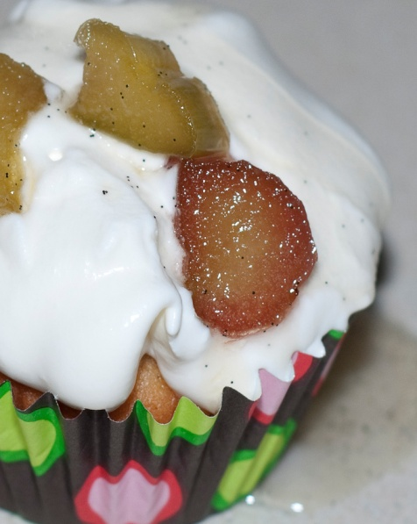
Martha Stewart’s Rhubarb Cupcakes with Whipped Cream
Makes 16 cupcakes

Cupcakes
Ingredients
- 1 ½ cups all-purpose flour
- ¼ teaspoon baking soda
- ¼ teaspoon baking powder
- ½ teaspoon coarse salt
- ½ cup (1 stick) unsalted butter, room temperature
- 2 cups sugar
- 2 large eggs, room temperature
- 1 teaspoon pure vanilla extract
- ½ cup sour cream, room temperature
- ¾ pound rhubarb, stalks trimmed and cut into ¼-inch dice (3 cups)
- 1 vanilla bean, halved lengthwise
Photo from the kitchen of PhDcupcaker
http://themalesfamily.com/phdcupcaker

- 1 cup water
Directions
- Preheat oven to 350○. Line standard muffin tins with paper liners. Whisk together flour, baking soda, baking powder, and salt.
- With an electric mixer on medium-high speed, cream butter and 1 cup sugar until pale and fluffy. Add eggs, one at a time, beating until each is incorporated, scraping down sides of bowl as needed. Beat in vanilla extract. Reduce speed to low. Add flour mixture in two batches, alternating with the sour cream, and beating until combined after each. Stir in 2 cups diced rhubarb.
- Divide batter evenly among lined cups, filling each three- quarters full. Bake, rotating tins halfway through, until a cake tester inserted in centers comes out clean, about 25 minutes. Transfer tins to wire racks to cool completely before removing cupcakes. Cupcakes can be stored up to 3 days at room temperature in airtight containers; remove liners before topping if desired.
- To make rhubarb topping, use the tip of a paring knife to scrape vanilla-bean seeds into a saucepan, reserving pod for another use (such as vanilla sugar). Add the water and remaining 1 cup sugar, and bring to a simmer, stirring to dissolve sugar. Remove from heat, and stir in remaining 1 cup rhubarb. Let cool completely. Remove rhubarb with a slotted spoon, and reserve. Return liquid to a simmer, and cook until reduced by half, 5 to 8 minutes. Let cool slightly, then return rhubarb to syrup. Once cool, rhubarb can be refrigerated in syrup up to 1 week in an airtight container; bring to room temperature before using.
- To finish, dollop a generous amount of whipped cream onto each cupcake, and top with rhubarb and some syrup. Serve immediately.
Whipped Cream
Ingredients
- 2 cups heavy cream
- ¼ cup confectioners’ sugar, sifted
Directions
- Whisk heavy cream until soft peaks form.
- Add confectioners’ sugar, and whish until combined

