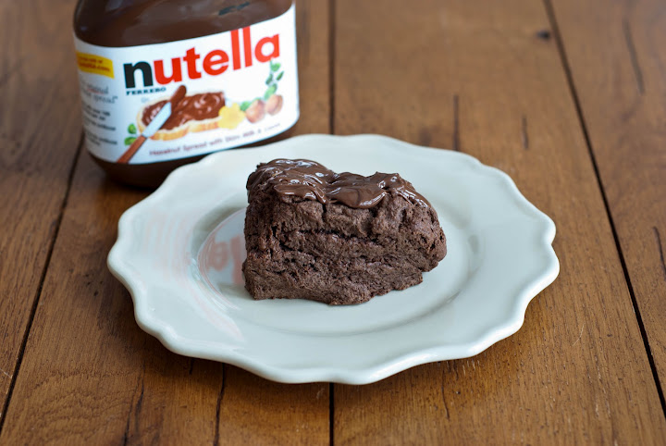
Nutella Scones
From BAKED EXPLORATIONS
By Matt Lewis & Renato Poliafito
Yield: 6-8 scones
Ingredients:
2 cups unbleached all-purpose flour
1/4 cup granulated sugar
1/4 cup dark unsweetened cocoa powder (like Valrhona)
1 tablespoon baking powder
1/2 teaspoon salt
6 tablespoons (3/4 stick) cold unsalted butter, cut into chunks
1 large egg
1/2 cup heavy cream
3/4 cup toasted hazelnuts, coarsely chopped
1/2 cup Nutella
Directions:
- Preheat the oven to 375 degrees F and place the rack in the center. Line a baking sheet with parchment paper.
- In a large bowl, whisk the flour, sugar, cocoa powder, baking powder, and salt until combined.
- Add the butter. Use your fingertips to rub it into the flour until the butter is pea size and the mixture is coarse.
- In a separate bowl, whisk together the egg and cream. Slowly pour the wet ingredients into the dry ingredients and stir until the dough just comes together. Gently and briefly knead the dough with your hands. Add the toasted hazelnuts and knead gently to incorporate. Flatten the dough into a rectangle approximately 6 by 12 inches ( it doesn't need to precise) and spread 1/4 cup of the Nutella on top in a crisscross pattern. Roll the dough up to make a cylinder about 6 inches long, turn it on its end, and gently flatten it into a disk about 1 3/4 inches high. Do not overwork the dough.
- Cut the dough into 6 or 8 wedges and place them on the prepared baking sheet. Bake the scones for 18-20 minutes, rotating the baking sheet halfway through, or until a toothpick inserted into the center of a scone comes out clean. Do not over bake.
- Transfer the scones to a wire rack to cool completely. Place the baking sheet with the parchment still on it underneath the rack.

Assemble the Nutella Scones:
- Heat the remaining 1/4 cup Nutella in a microwave until pourable, about 10 seconds on high. Pierce the tops of the scones a few times with a fork. Use a spoon ( or two spoons-one to scoop, one to scrape) to drip the warm Nutella in a zigzag pattern over the tops of the hot scones. Transfer them to a refrigerator to set for 5 minutes, then serve immediately.
Most scones have a lifespan of 24hours or less; however, these scones taste pretty darn good on day two provided you wrap them tightly and store them at room temperature.
*Baked Note*
My number –one piece of advice for those new to scone making: Do not knead too much. I think we must be born with an urge to create perfect, smooth, pliable, pillowy dough, resist the temptation. Stop working the dough the minute it comes together. Do not worry if these are a few dry bits scattered throughout.

